Moon Phases to Predict human behaviour

Renato Francisco Goedert
Waterford, Ireland
renato.goedert@gmail.com

^{17th} December 2025
Abstract— This study aims to leverage a project realized for the module of Programming for Artificial Intelligence, where public datasets were used to investigate a correlation between crimes and moon-phases, to demonstrate the author capacity for data analysis and technical writing. The public datasets used for this study is the Chicago Crimes Datasets and the NASA moon-phases dataset from the years of 2020 to 2025; Data ingestion, preprocessing, and exploratory analysis were conducted using Python-based tools, including Pandas, NumPy, and Seaborn. Machine learning models implemented with the Scikit-learn library were applied to evaluate potential predictive relationships between crime frequency and lunar phases.. The results strongly demonstrated that no significant statistics were found between the Chicago Crimes dataset and the NASA Moon Phases dataset, further debunking this cultural myth.
Keywords— Moon, Crimes, Chicago, NASA, Datasets, Artificial Intelligence, AI Models, Analysis

Introduction
Human societies have long speculated about connections between human behaviour and the astronomical phenomena, with the existence of a common cultural belief suggesting that full moons may increase crime, accidents, or other unusual events. Although scientific evidence for such effects is limited, a few studies have identified small but notable behavioural fluctuations associated with lunar phases [1], [2].
In parallel, the availability of large-scale public datasets, along with advances in computational power and analytical methods, has improved significantly in recent years. This progress is reflected in the growing number of studies analysing the influence of temporal, environmental, and socio-contextual factors on crime incidence, including time of day, seasonality, and neighbourhood characteristics[3] [4].
Despite extensive research on modelling crime, utilization of astronomical data-such as Moon phases-is extremely rare. This lays out the setting for a novel investigation.
The present project integrates two datasets to explore this.
- Chicago crime records
- NASA lunar phase data
These datasets proceed to be processed through a Python-based pipeline, which involves programmatic retrieval, preprocessing, transformation, and later storage on the local database. The combined data are then analysed to examine whether lunar phases correspond with measurable variations in crime patterns, thereby aligning with the study objectives.

related work
Research into the effects of lunar phases on human behaviour has yielded inconsistent results: some studies claim that a full moon has no significant effect on either psychological or behavioural patterns; other studies indicate small, yet detectable, fluctuations. For instance, Owen [1] reported small-scale behavioural disturbances linked to certain phases of the moon, while Raison et al. [2] concluded that most of the observed effects were statistically insignificant. Overall, evidence from scientific research implies very weak or non-uniform correlations.
On the other hand, crime analysis research has widely considered temporal, environmental, and socio-contextual factors. Ratcliffe [3] remarks that systematically varying features in daily routine, seasonality, and neighbourhood characteristics may explain variations in crime magnitude. The latter studies typically use structured datasets and statistical modelling, with only a few considering astronomical variables; thus, the effect of lunar cycles is still largely unexamined.
As a result, existing research has largely treated crime modelling and lunar influence studies as separate domains. The lack of integrated analyses combining crime data with lunar phase information reveals a gap in the literature that this study seeks to address.

Methodology
For this study a straightforward architecture was applied. The data processing pipeline was implemented using Python; NumPy and Pandas for the numerical calculations and manipulations; Seaborn for graphical analysis; Scikit-Learn library for AI models evaluation.
The Chicago and NASA datasets were retrieved via a Python-based data ingestion script, which also executed all data wrangling operations, including preprocessing, data cleaning, normalization, and schema alignment.
Following preprocessing, the resulting structured datasets were persisted in a containerized PostgreSQL relational database and deployed using Docker, which ensures consistency, portability and reproducibility. A high-level flow diagram is as follows:
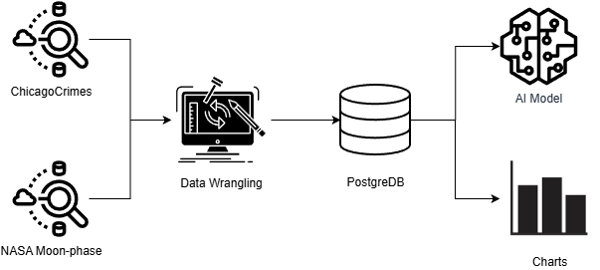
Figure 1 - Data Process Diagram

Moon-phases Dataset

As the proposed research question topic states and examines correlations between lunar phases and incidents in the city of Chicago, three datasets were selected to perform a full and detailed analysis. The first dataset used was the NASA Moon Phase and Libration dataset (2021-2025). It stores columns that include lunar age, phase percentage, and Earth-Moon distance, retrieved from NASA's resources and calculated hourly. This dataset was picked for its scientific accuracy, which is crucial when doing correlation analysis.[5]

Processing data
The data processing was done using Python 3.12, and a layered architecture that separates cleaned data transformation from raw data ingestion. Raw JSON files of NASA moon-phases data were uploaded to a “Supabase” PostgreSQL cloud database programmatically and the supabase-py client library (v2.23.0) was used for it.
In this case, batch upload was used, and 500 records per batch were processed to manage API rate limits and memory limitations. The upload script uploaded 43,825 hourly lunar records over the chosen five years range. Supabase was chosen as team's decision to satisfy project requirements and also for its cloud architecture, built-in authentication, and easy integration with Python code.[7]

Data Transformation
The moon phases dataset needed transformation from hourly to daily aggregates to match the crime and traffic datasets in terms of granularity and precision.
Pagination was used to resolve Supabase's default 1000-record query limit, loading data in batches of 500 using range-based queries.
The transformation used in 03_moon_data_ cleaning.ipynb uses grouping operations with pandas (2.3.3 version),[6] calculating daily averages for phase percentage, lunar age, distance, and diameter.
Further the phase percentages were mapped to lunar categories (New Moon, Waxing Crescent, First Quarter, Waxing Gibbous, Full Moon) based on existing astronomical thresholds. This reduced over 40000 hourly records to 1825 daily aggregates making cleaned dataset normalized and ready for correlation analysis

Chicago Crimes Dataset
The Chicago crimes dataset was chosen as the dataset to base the crime statistics for the project, because it possesses a high degree of quality and a well-documented public API, allowing for easy programmatic access. Moreover, the crimes entries are recorded hourly, offering a suitable basis for integrating with the lunar phase datasets.

Fetching Data
The data set was downloaded via an official API to the Chicago Data Portal. The data were filtered to include only records from the year 2020 onward to provide a good temporal match with the other data sets in the project. Besides, the default API limits the fetch requests to 1000 entries, so an explicit limit filter of 5 million record was added to bypass this limitation.
Once obtained, the raw data was persisted in a local Postgres instance. This approach focus on minimising the delay related to fetching all data from the cloud, as well as avoiding overloading the database with the raw data. Additionally, storing raw data locally allows for efficient re-runs of the cleaning pipeline whenever adjustments are required

Data wrangling
The dataset was loaded from the local database after ingestion. The first preprocessing step undertaken was analysing all attributes available and selecting only those fields that were of essence to the objectives. This included the following columns:
- date
- primary_type
- location_description
- arrest
- domestic
The dataset also underwent trough a normalization process on the date column to ensure a consistent temporal granularity with that used for the traffic and lunar datasets..
The subsequent wrangling step ensured consistency of format, removed any discrepancies, and standardized any variation in crime type labels. This transformation was necessary both to reduce noise and to ensure that reliable analysis of categorical values was possible.
The most challenging preprocessing step concerned the location_description field. The main reason being the fact that this field was composed of a large number of highly granular categories. The function to clean this field consisted of a standardized format and aggregation into larger and analytically meaningful groups, enhancing readability, improving reliability and further reducing sparsity.
Finally, after all cleaning, normalisation and transformation had been done, the processed dataset was uploaded to the Supabase cloud database in batches of 5,000 records to avoid limitations in request size. Total records inserted were 288,762.

Results and Evaluation

Scikit-Learn
Scikit-learn was chosen as one of the libraries for its efficient and reliable tools for cross-validation and evaluation. Also, benign is stated as a good learning library for any experimental analysis and comparative modeling. [n4]

Linear Regression
The first AI model to evaluate the relationship between lunar phases and daily crime and traffic accidents, with the use of scikit-learn, was a Linear Regression. Following best practices, a five-fold cross-validation was applied to the model, where the R² (Coefficient of determination) was set as the evaluation metric. [n1]
For the daily crime occurrence in the chicago_crimes dataset, the model mean R² value of -0.770 established that the model, using the moon phases, showed a substantially worse capability to preview the occurrence of daily crimes than the baseline predictor. Although some coefficients, e.g. Full Moon, exhibited a positive value, the strongly negative R² value indicates that no meaningful relationship could be raised by the model. [n2]
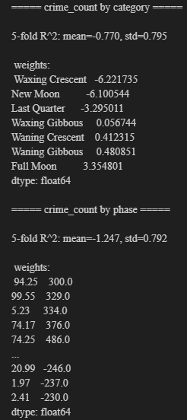
When trying the same model to preview the daily Traffic incidents, the R² value was raised to -0.021. While showing some improvement compared to the daily crimes, the value, effectively 0, shows no prediction power for the model. The same considerations for the coefficients on the crimes dataset are valid for the accidents. [n2]
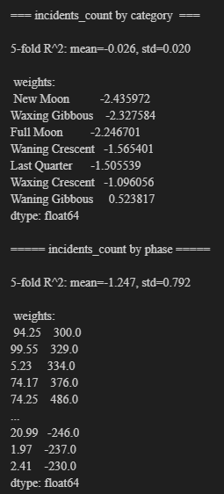
Overall the results indicate that the datasets do not support a linear relationship between the lunar phases and the crimes/accidents. Furthermore, the result could be the advent of a linear model's limitations of using the R² for sparse count-based data [n3], which motivates the exploration of alternative models.

Random Forest
To assess the Linear Regression limitations the Random Forest models were implemented; this new model aims to capture any nonlinear relationships that cannot be captured by a Linear Regression model. With hyperparameters set to balance model stability and generalization, including a large number of estimators and minimum leaf size to reduce overfitting. [Z]
Even with the use of a more complex nonlinear model, the cross-validated R² scores remained close to or below zero for both crime and traffic count. This strengths the result of the Linear Regression model, where there is no signal of a predictive capability of the moon phases for daily crimes and accidents. [n2]
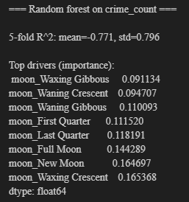
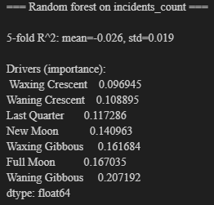

Poisson Regression
Given that both response variables represent non-negative count data, the Poisson regression rises as an alternative. The model was determined to run using five-fold cross-validation and the mean Poisson deviance metric, as they evaluate better count-based outcomes than R². [n4]
For the daily crime counts, the new model achieved the mean deviance value of 15.732, representing a moderate variability across folds. The coefficients, again, were small in magnitude, with New Moon and Full Moon showing slightly positive scores. However, these were negligible when compared to the overall variance in data. [n5]
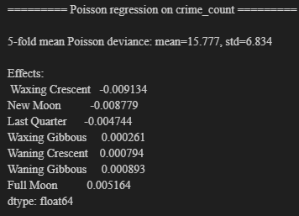
In the case of traffic incidents, the Poisson model lowered the value to 6.066, a substantially lower mean that reflects a better fit due to the lower variance of the dataset. Nevertheless, the lunar phase coefficients remained close to zero. [n5]
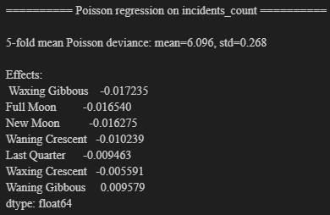

Conclusion

References
- R. C. J. Raison, S. Klein, and A. T. Friedman, “The Moon and madness reconsidered,” Journal of Affective Disorders, vol. 93, no. 1–3, pp. 199–203, 2006.
- A. Owen, “Lunar cycles and human behaviour: Is there a link?” Psychological Reports, vol. 68, no. 3, pp. 854–856, 1991.
- J. Ratcliffe, Crime Analysis for Problem-Solvers in 60 Small Steps, U.S. Department of Justice, 2015.
- M. Abdel-Aty and A. Haleem, “Analyzing traffic crashes using multivariate statistical methods,” Accident Analysis & Prevention, vol. 42, no. 4, pp. 1407–1414, 2010.
- E. Wright, “Moon Phase and Libration, 2021-2025,” NASA Scientific Visualization Studio, 2025. [Online]. Available: https://svs.gsfc.nasa.gov.
- W. McKinney, “Data structures for statistical computing in python,” Proceedings of the 9th Python in Science Conference, vol. 445, pp. 51–56,2010.
- G. Van Rossum and F. L. Drake, The Python Language Reference, Python Software Foundation, 2024.
- [n1] DataCamp. “K-Fold Cross Validation in Machine Learning: A Practical Guide,” 2024. Available: https://www.datacamp.com/tutorial/k‐fold‐cross‐validation
- [n2] T. Hastie, R. Tibshirani, and J. Friedman, *The Elements of Statistical Learning: Data Mining, Inference, and Prediction*, 2nd ed. New York, NY, USA: Springer, 2009.
- [n3] Quantics, “Why R² is not a measure of goodness-of-fit,” 2022. Available: https://www.quantics.co.uk/blog/r-we-squared-yet-why-r-squared-is-a-poor-metric-for-goodness-of-fit/
- [n4] A. Géron, *Hands-On Machine Learning with Scikit-Learn, Keras, and TensorFlow: Concepts, Tools, and Techniques to Build Intelligent Systems*, 2nd ed., O’Reilly, 2019.
- [n5] P. McCullagh and J. A. Nelder, *Generalized Linear Models*, 2nd ed. London, UK: Chapman & Hall, 1989.
- S. J. Taylor and B. Letham, "Forecasting at scale," The American Statistician, vol. 72, no. 1, pp. 37–45, 2018.

